

**School Sportsmanship Award**

Northcote College

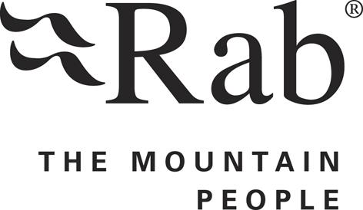

**Random act of kindness Award**

Nathaniel Dalton-Wilson Botany Downs College

**Placegetter Draws 2 x $100 Gift Vouchers**

Hannah McCall Baradene

Alena Oparina Long Bay College