 

**Round 4**

**School Sportsmanship Award**

**Junior Round - Albany Junior High School**

**Senior Round - Elim Christian School**

**RAB Placegetter Draws $100 Gift Vouchers**

**Moana & Zhen - Sacred Heart**

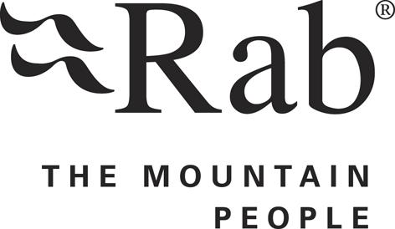

**The Trusts Volunteers awards**

**William, Chris, Tegan, Kimi, Zhen**